This application is to be completed by an ACCSC-accredited school to request the addition of an official diminutive name (e.g., “nickname”) to the institution’s College 360 profile. The diminutive name is to be used exclusively for approved purposes in the institution’s advertising and promotion materials. A school may be approved for a maximum of two (2) diminutive names, each requiring a separate application.

To be submitted at least 30 days prior to a school’s intended use of a diminutive name.

GUIDELINES FOR SUBMISSION
- The school must ensure that the Payment Submission Form of this application is included. Please ensure that the form lists the correct school, fee amount, and check information. If the school would like to submit payment via credit card, please contact the ACCSC office.
- The school must provide a response to all items in this application, along with any relevant supporting documentation. Please do not copy and paste information from previous applications. If the application is deemed incomplete, the Commission may determine that a new submission is needed prior to review.
- The completed application should include only the required information and not exceed 100 pages. Unless specifically requested, do not provide copies of the full school catalog or information that does not pertain to the items in this application.
- Please review the application prior to final submission to ensure that all required information is provided, that all intended attachments are included, and that the submission is free of errors and typos.

ELECTRONIC SUBMISSION FORMAT REQUIREMENTS
- Electronic Submissions submitted via e-mail will not be processed. Please upload all submissions to the ACCSC College360 database. The school will receive an e-mail confirmation that the file has been received within 24 hours of the submission.
- The school’s response must be prepared in accordance with ACCSC’s Instructions for Electronic Submission (e.g., prepared as one continuous PDF document with the required bookmarks).
- Please visit the ACCSC website for specific resources and guidance regarding how to successfully complete and submit this application.

APPLICATION PROCESSING FEE
Please submit payment to ACCSC for processing and include a statement identifying the corresponding application(s). Note: Please ensure that the Payment Submission Form for this application is included and identifies the corresponding application(s), fee amount, and check number.
- Application for a Diminutive Name: $350 per application

Please note that should an application be deemed incomplete, the school will receive a request for additional information via email. If upon review of the additional information, the application is still incomplete, the school will be assessed a $250 additional information processing fee for the submission of the additional information, which must be paid upon the submission of the response.
INCORRECT APPLICATION FEE
Please ensure that the school is utilizing the correct application. Upon review of the application, if determined that the school should have utilized a different application, a $250 Incorrect Application Fee will be assessed.
I have read and understand the Guidelines for Submission and the Electronic Submission Format Requirements set forth above and I further understand that a failure to adhere to these guidelines and requirements will result in either a delay in the processing of or return of this application.

I certify that the information herein and attached hereto is correct.
Attestations
☐ By checking this box, I attest that the school submitting this application confirms that the use of the diminutive name applied for herein does not and may not be used in any way to misrepresent the school, its training, program(s), location, or accredited status.
☐ By checking this box, I attest that the school administration officials:
- Have reviewed ACCSC’s advertising standards and guidelines set forth in Section IV (B) & Appendix IV, Substantive Standards, Standards of Accreditation and
- Confirm that the use of the diminutive name as applied for herein does not and may not be used to misrepresent the school, its training, programs, or location.
☐ By checking this box, I attest that the school submitting this application accepts the responsibility to confirm and ensure that the use of the diminutive name applied for herein meets all state licensing requirements.
☐ By checking this box, I attest that the school submitting this application accepts the responsibility to confirm and ensure that the use of the diminutive name applied for herein does not violate any trademark or copyright law.
Signed:
Name | Signature | Title | Date

This application is to be completed by an ACCSC-accredited school to request the addition of an official diminutive name (e.g., “nickname”) to the institution’s College 360 profile. The diminutive name is to be used exclusively for approved purposes in the institution’s advertising and promotion materials. A school may be approved for a maximum of two (2) diminutive names, each requiring a separate application.

To be submitted at least 30 days prior to a school’s intended use of a diminutive name.

School # | School Name  (as listed in College360) | Type |  | City | State
 |  | Main: | ☐
 |  | Branch: | ☐

How is the school legally established? | If a Corporation owns the school, provide the Corporation’s Name

Contact | Title/position | Phone | Email

Does the school have an approved satellite location(s) |  | If Yes, please list the satellite location(s), including Satellite Number, city, and state*
yes | ☐
no | ☐
* Upon approval of the Diminutive Name for the main/branch, the Diminutive Name will also be acknowledged for any applicable satellite location(s).

Proposed Diminutive Name
Note: Only one diminutive name per application. Please do not add additional lines.

Diminutive Name of School | Effective Date of Use  (month/day/year)

Required Supporting Information
- If applicable, a copy of the state license recognizing the use of the diminutive name .
- A justification that the diminutive name is reasonably related to the school’s official name on record and does not misrepresent the school, its training, program(s), location, or accredited status.

INSTITUTIONAL DEVELOPMENT
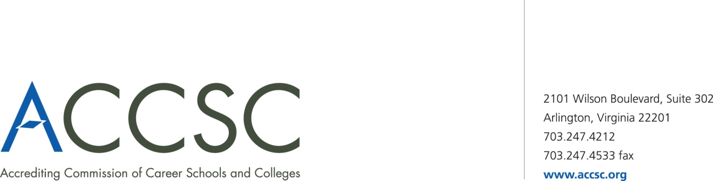
PAYMENT SUBMISSION FORM FOR APPLICATION SUBMISSIONS

SCHOOL #(s) | SCHOOL NAME(s) | CITY | STATE

APPLICATION TYPE(s) | NAME OF PROGRAM(s)  (if applicable) | PAYMENT AMOUNT(s)  (Enter payment amount for each application type)

TOTAL PAYMENT AMOUNT | CHECK NUMBER

NAME OF CONTACT PERSON | TITLE | PHONE NUMBER | EMAIL
* Please submit a payment submission form with each check payment.

Submit To: Operations Department
Accrediting Commission of Career Schools and Colleges
2101 Wilson Boulevard, Suite 302
Arlington, VA 22201

