**ACCSC School Submission Center**

All ACCSC schools must upload responses directly to the Commission via ACCSC’s College 360 solution. Keep in mind the school’s response must be submitted as one continuous Portable Document Format (“PDF”) file that has been prepared using Adobe Acrobat software (version 8.0 or higher) and which has a .pdf extension as part of the file name.

To access the College 360 system, all you need is a computer, internet browser, andconnection to the Internet. Although many browsers will work, Internet Explorer 8 or greater, or Mozilla Firefox 5, or higher, is recommended for use. Other browsers such as Safari should work, but may exhibit odd behavior due to slight differences in the way browsers interpret web pages.

The College 360 system is encrypted using a third party certificate. This helps to ensure that data transmitted between the user’s computer and College 360 is not readable to another system, while in transit across the internet. ACCSC uses 128bit encryption, ensuring secure communication and transmission of school data.

ACCSC has issued the first two modules of the **Blueprints for Success Series**: [Organizing an Effective Electronic Submission](http://www.accsc.org/UploadedDocuments/Blueprint%20for%20Success%20-%20Organizing%20an%20Electronic%20Submission%20FINAL.pdf) and [Preparing a Comprehensive Response for Commission Consideration](http://www.accsc.org/UploadedDocuments/Blueprint%20for%20Success%20Preparing%20a%20Comprehensive%20Response%20for%20Commission%20Consideration%20%20FINAL.pdf) which provide a framework for submitting a well-documented, organized, electronic response for Commission consideration. ACCSC encourages the school to review these modules prior to formulating its response to this letter. More information is available under the [Resources section](http://www.accsc.org/Resources/Blueprints-for-Success.aspx) at [www.accsc.org](http://www.accsc.org).

**Upload Instructions**

1. Open your browser.
2. In your address bar type: <https://college360.accsc.org>

You will be presented with the College 360 logon as shown below.

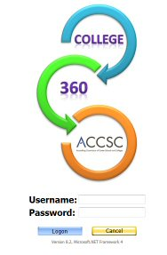

Logon securely using your school’s username and password. Please note that the passwords utilized by institutions to access the Annual Report Portal are the same to access the School Submission section of the College 360 database. Any password requests must be made by the school director via e-mail to C360@accsc.org.

1. Once you have logged into the system, select “DMS” from the menu bar as illustrated below:

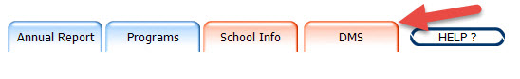

1. Select the “School Submission” folder.

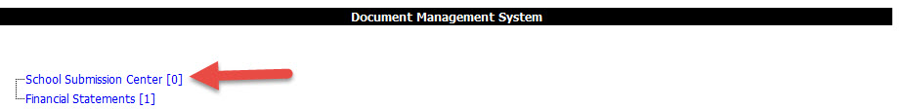

1. Upon selecting the folder, you will see a list of existing files and will be presented with a form and upload options, as shown below:

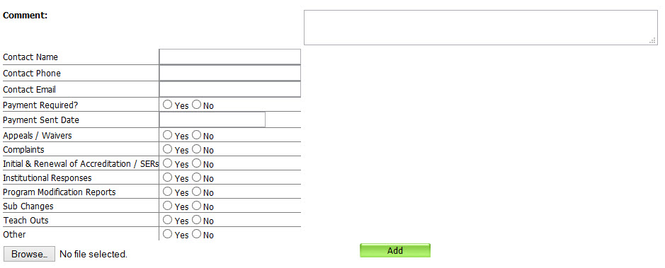

Complete the form with the correct contact information, payment information if applicable and response type. Please ensure all form fields are filled out.

1. Once the form is complete, select the “Browse” button and browse to the file to be uploaded. Select the file.
2. Finally select “Add” to upload the file into the DMS*.* Schools may not modify files after being uploaded.
3. If payment is required, please mail a check directly to ACCSC for processing and include a statement identifying the corresponding application(s). Applications will be processed once payment has been received.