To be submitted at least 30 days prior to the expansion of a main school, branch campus, or satellite location (Section IV (B)(1)(a), Rules of Process and Procedure, Standards of Accreditation).

Note: Main schools and branch campuses may expand facilities into either contiguous or non-contiguous space. Satellite locations may only expand into contiguous space. The Commission considers expansion into space that is more than one mile away to be a separate facility (Section IV (B)(1), Rules of Process and Procedure, Standards of Accreditation).

GUIDELINES FOR SUBMISSION
- The school must ensure that the provided Institutional Development Payment Submission Form is included with the submission. Please ensure that the form lists the correct school name, fee amount, and check information. If the school would like to submit payment via credit card, please contact the ACCSC office.
- The school must provide a response to all items in this application, along with any relevant supporting documentation. Please do not copy and paste information from previous applications. If the application is deemed incomplete, the Commission may determine that a new submission is needed prior to review.
- The completed application should include only the required information and not exceed 100 pages. Unless specifically requested, do not provide copies of the full school catalog or information that does not pertain to the items in this application.
- Please review the application prior to final submission to ensure that all required information is provided, that all intended attachments are included, and that the submission is free of errors and typos.
- Incorrect application submissions will incur a $250 Incorrect Application Fee.

ELECTRONIC SUBMISSION FORMAT REQUIREMENTS
- Electronic Submissions submitted via e-mail will not be processed. Please upload all submissions to the ACCSC College360 database. The school will receive an e-mail confirmation that the file has been received within 24 hours of the submission.
- The school’s response must be prepared in accordance with ACCSC’s Instructions for Electronic Submission (e.g., prepared as one continuous PDF document with the required bookmarks).
- Please visit the ACCSC website for specific resources and guidance regarding how to successfully complete and submit this application.

I have read and understand the Guidelines for Submission and the Electronic Document Format Requirements set forth above and I further understand that a failure to adhere to these guidelines and requirements will result in either a delay in the processing of or return of this application.

I certify that the information herein is correct and attached hereto is correct.

Name | Title | Email
Signature |  |  | Date

School # | School Name | Type |  | City | State
 |  | Main: | ☐
 |  | Branch: | ☐

Contact Person | Phone | Email

Facility Expansion Address  (Including City, State, and Zip Code) | Distance From Main School / Branch Campus (in miles) | Scheduled Date of Expansion (month/day/year)

Application Processing Fee
Please mail a check directly to ACCSC for processing and include a statement identifying the corresponding applications(s). Note: Please ensure that the Payment Submission Form for this application is included and identifies the corresponding application(s), fee amount, and check number.
- Facility Expansion Report: $500
Please note that should an application be deemed incomplete, the school will receive a request for additional information via email. If upon review of the additional information, the application is still incomplete, the school will be assessed a $250 additional information processing fee for the submission of the additional information, which must be paid upon the submission of the response.

Incorrect Application Fee
Please ensure that the school is utilizing the correct application. Upon review of the application, if determined that the school should have utilized a different application a $250 Incorrect Application Fee will be accessed.

Required Supporting Documentation
      - A complete description and explanation (purpose) of the facility expansion (e.g., classroom space for program, office space, etc.).
      - A list of all programs to be offered at the proposed expanded facility using the ACCSC Program chart.
      - A copy of state license for the expanded facility. If the state (or applicable regulatory agency) does not require approval, documentation from the agency to that effect must be submitted.
      - A copy of the Occupancy permit and/or other documentation of current compliance with local fire, safety and sanitation requirements for the expansion facility as required by appropriate regulatory authorities.
      - A copy of the executed lease agreement or purchase agreement accompanied by a sketch of the floor plan of the facility and site plan, to include address if different from above.
      - A description of ready access to all resources and services available to students attending programs offered at the facility (Section IV (B)(1), Rules of Process and Procedure, Standards of Accreditation).

INSTITUTIONAL DEVELOPMENT
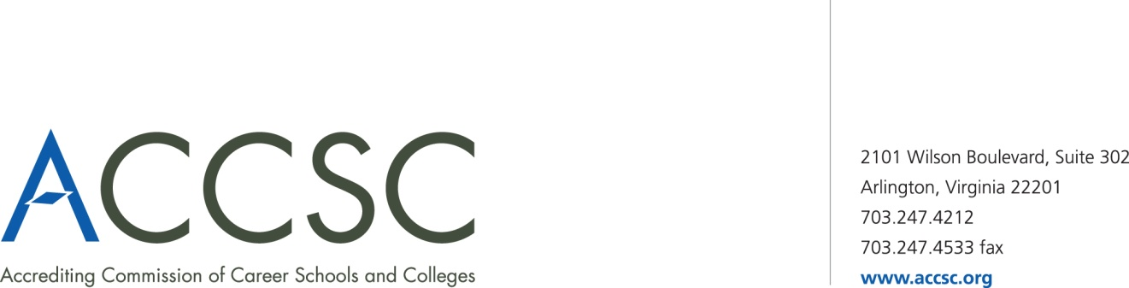
PAYMENT SUBMISSION FORM FOR APPLICATION SUBMISSIONS

Please submit a copy of this form with both the application and check payment. Applications will not be processed until payment has been received.

SCHOOL #(s) | SCHOOL NAME(s) | CITY | STATE

APPLICATION TYPE(s) | NAME OF PROGRAM(s)  (if applicable) | PAYMENT AMOUNT(s)  (Enter payment amount for each application type)

TOTAL PAYMENT AMOUNT | CHECK NUMBER

NAME OF CONTACT PERSON | TITLE | PHONE NUMBER | EMAIL

Submit To: Operations Department
Accrediting Commission of Career Schools and Colleges
2101 Wilson Boulevard, Suite 302
Arlington, VA 22201

