To be submitted in any instance where a portion of an approved program is taught by or at another entity other than the ACCSC-accredited institution via a consortium or partnership agreement (Section IV (E)(6)(a)(vi), Rules of Process and Procedure, Standards of Accreditation). This application must be submitted at least 45 days before the agreement goes into effect. The school must receive approval prior to implementation.
GUIDELINES FOR SUBMISSION
1. The school must ensure that the Payment Submission Form of this application is included. Please ensure that the form lists the correct school, fee amount, and check information. If the school would like to submit payment via credit card, please contact the ACCSC office.
2. The school must provide a response to all items in this application, along with any relevant supporting documentation. Please do not copy and paste information from previous applications. If the application is deemed incomplete, the Commission may determine that a new submission is needed prior to review.
3. The completed application should include only the required information and not exceed 100 pages. Unless specifically requested, do not provide copies of the full school catalog or information that does not pertain to the items in this application.
4. Please review the entire submission prior to final submission to ensure that all required information is provided, that all intended attachments are included, and that the submission is free of errors and typos.

ELECTRONIC SUBMISSION FORMAT REQUIREMENTS
- Electronic Submissions submitted via e-mail will not be processed. Please upload all submissions to the ACCSC College360 database. The school will receive an e-mail confirmation that the file has been received within 24 hours of the submission.
- The school’s response must be prepared in accordance with ACCSC’s Instructions for Electronic Submission (e.g., prepared as one continuous PDF document with the required bookmarks).
- Please visit the ACCSC website for specific resources and guidance regarding how to successfully complete and submit this application.

I have read and understand the Guidelines for Submission and the Electronic Submission Format Requirements set forth above and I further understand that a failure to adhere to these guidelines and requirements will result in either a delay in the processing of or return of this application.

I certify that the information herein and attached hereto is correct.

Name | Title | Email
Signature |  |  | Date

School # | School Name | Type |  | City | State | Degree Granting
 |  | Main: | ☐ |  |  | Yes: | ☐
 |  | Branch: | ☐ |  |  | No: | ☐

Contact Person | Phone | Email

Proposed Consortium / Partnership Entity | Address | City | State | Distance From School Campus  (in miles)

Is the Entity Recognized by another Agency |  | If Yes, List Agency  (e.g. Programmatic Accreditor, State, Other)
Yes: | ☐
No: | ☐

Program Title  (e.g. Business Administration) | Length of Program  (in Months) | Credential | Percentage of Program Taught by or at Partnership Entity

***

The school retains responsibility for the quality of the courses of study and programs offered, as well as the achievement of expected and acceptable outcomes, irrespective of any consortium, partnership, or contractual agreement entered into with a third party in order to provide any portion of a program or course of study.

Name | Title | Email
Signature |  |  | Date

Application Processing Fee
Please mail a check directly to ACCSC for processing and include a statement identifying the corresponding applications(s). Note: Please ensure that the Payment Submission Form for this application is included and identifies the corresponding application(s), fee amount, and check number.
- Processing Fee of $1,500 per application.

Please note that should an application be deemed incomplete, the school will receive a request for additional information via email. If upon review of the additional information, the application is still incomplete, the school will be assessed a $250 additional information processing fee for the submission of the additional information, which must be paid upon the submission of the response.

Incorrect Application Fee
Please ensure that the school is utilizing the correct application. Upon review of the application, if determined that the school should have utilized a different application, a $250 Incorrect Application Fee will be assessed.

Required Supporting Documentation
A. Consortium/Partnership Authorizations
- Describe the school’s educational administration structure which assures the proper oversight of the proposed consortium/partnership agreement.
- Provide a copy of the consortium/partnership agreement.
- Provide program approval from the state for which the consortium/partnership entity resides, or evidence that this requirement is not required.
- If the partner is recognized by another agency, provide evidence of the consortium/partnership entity’s status with the agency (e.g. programmatic accreditor, state, other).
Program Information
B. Program Information
- Please provide an Outline of a Degree Program, Outline of a Non-Degree Program, or an Allocation of Hours for Clock Hour Programs (for clock hour only programs), as applicable for each program to be offered via the consortium/partnership agreement.
- Please list the courses that will be offered by or at the consortium/partnership entity.
- Please provide a copy of disclosures to students regarding the consortium/partnership agreement and any expectations of the students (e.g., education oversight, travel requirements, equipment needs, etc.).
- Describe the equipment available for students and how the equipment is sufficient in quality and quantity for the number of students.

C. Facilities and Advertising
- Sketch of floor plan and layout of the facility where the training will be offered. Please only include the portion of the facility that the school will be utilizing.
- Provide samples of the program’s proposed advertising and other promotional materials (e.g. brochures, television, radio, surveys, etc.).

D. Education Delivery Information (For any portion of the program taught by the consortium/partnership entity)
1. Complete the following chart
Program Title  (e.g. Business Administration) | Total Program Hours |  | Total Program Hours  Taught by Partnership Entity
 | Clock Hours | Credit Hours | Clock Hours | Credit Hours

2. Provide the following information for the instructor(s) responsible for the delivery of education by the consortium/partnership entity and demonstrate that their qualifications are consistent with the faculty qualification requirements in accordance with Section III (B) Substantive Standards, Standards of Accreditation:
TECHNICAL/OCCUPATIONAL FACULTY
Instructor Name | Course(s) Taught  Title(s) / Number(s) | Degree Earned  Include: Subject, Credential, Year & Institution(s) | Practical Work Experience  (Note: Instructional experience does not qualify as practical work experience)
 |  |  | Job Title, Place of Employment, and Description of Work Experience | From (m/y) | To (m/y)

FACUTLTY TEACHING GENERAL EDUCATION and OTHER COURSES
Instructor Name | Course(s) Taught  Title(s) / Number(s) | Degree Earned  Include: Subject, Credential, Year & Institution(s) | Related Subject Matter Credits Earned
 |  |  | Course Number & Title | Credits | Type (U/G) | Year

INSTITUTIONAL DEVELOPMENT
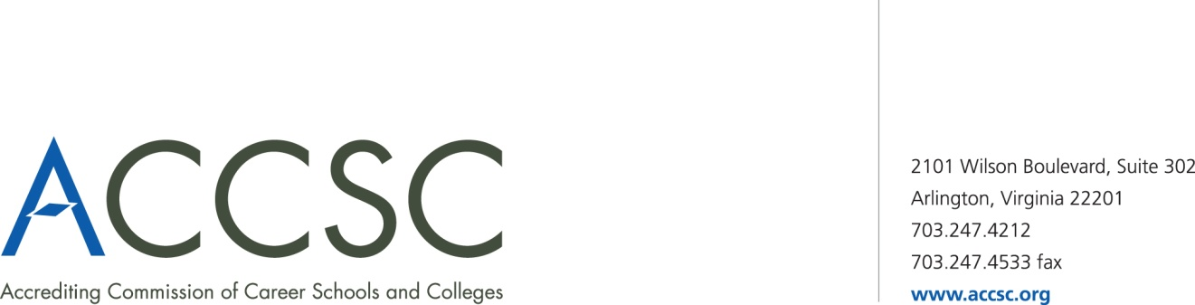
PAYMENT SUBMISSION FORM FOR APPLICATION SUBMISSIONS

Please submit a copy of this form with both the application and check payment. Applications will not be processed until payment has been received.

SCHOOL #(s) | SCHOOL NAME(s) | CITY | STATE

APPLICATION TYPE(s) | NAME OF PROGRAM(s)  (if applicable) | PAYMENT AMOUNT(s)  (Enter payment amount for each application type)

TOTAL PAYMENT AMOUNT | CHECK NUMBER

NAME OF CONTACT PERSON | TITLE | PHONE NUMBER | EMAIL

Submit To: Operations Department
Accrediting Commission of Career Schools and Colleges
2101 Wilson Boulevard, Suite 302
Arlington, VA 22201

Any program where 50% or more of the total number of clock or credit hours is offered via a consortium/partnership requires review and approval by the Commission. In all instances a school may not award more than 75% of the total number of clock or credit hours required in a program via a consortium or partnership (Section II (A)(8)(b), Substantive Standards, Standards of Accreditation). Additionally, if the school chooses to utilize the more than 50% option it may impact the financial aid eligibility for that program.

