**Schools may apply for recognition of English as a Second Language (ESL) Courses that are successfully articulated with and support the school’s career-oriented vocational program(s), have objectives related to occupational training and concepts, and provide students with adequate linguistic proficiency for obtaining employment in the field for which they are or will be trained (*Section II (D)(2 (a), Substantive Standards, Standards of Accreditation*)*.***

**GUIDELINES FOR SUBMISSION - PLEASE REVEW PRIOR TO SUBMISSION:**

1. The school must ensure that the **Payment Submission Form** of this application is included and identifies the correct fee amount, check information, and indicates the correct and applicable school(s).

2. The school must provide a response and all appropriate supporting documentation to all items below. The Commission may not process the application and may require a new submission from the school if the application is found to be incomplete.

3. The completed application should not exceed **100 pages** total and should include only the required information. Do not provide copies of the school catalog or information that does not pertain to the items in this application.

4. Prior to final submission of this application, review the entire submission to ensure that all required information is provided, that all intended attachments are included, and that the submission is free of errors and typos.

**ELECTRONIC SUBMISSION FORMAT REQUIREMENTS:**

1. Electronic Submissions may not be transmitted to the Commission via e-mail.
2. The school’s response must be prepared in accordance with ACCSC’s [Instructions for Electronic Submission](http://www.accsc.org/UploadedDocuments/Instructions%20for%20Electronic%20Submission%204%201%202014%20web.docx) (e.g., prepared as one Portable Document Format (“PDF”) file that has been prepared using Adobe Acrobat software (version 8.0 or higher) and which has a .pdf extension as part of the file name). The school will receive an e-mail confirmation that the file has been received within 24 hours of the submission.
3. Please visit the ACCSC website for specific resources and guidance regarding how to successfully complete this application: [Forms and Reports](https://www.accsc.org/Forms-and-Reports/Forms-And-Reports.aspx)-Guidance/Sample Applications.ACCSC encourages the school to review this module prior to submitting this application.
4. Additionally, **do not copy and paste** answers from previous applications.

I certify that the information herein and attached hereto is correct.

|  |  |  |  |
| --- | --- | --- | --- |
| **Name** | **Signature** | **Title** | **Date** |
|  |  |  |  |

|  |  |  |  |  |  |  |  |
| --- | --- | --- | --- | --- | --- | --- | --- |
| **School #** | **Name of School** | **Type** | | **City** | **State** | **Degree Granting** | |
|  |  | Main: |  |  |  | Yes: |  |
| Branch: |  | No: |  |

|  |  |  |
| --- | --- | --- |
| **Contact Person** | **Phone** | **Email** |
|  |  |  |

|  |  |  |  |  |  |
| --- | --- | --- | --- | --- | --- |
| **Course Title** | **Instructional Clock Hours** | **Academic Credit Hours** | **Type of ESL Courses** | | **Proposed Start Date**  *(month/day/year)* |
|  |  |  | Front Loaded Courses: |  |  |
| Integrated Courses: |  |

* ESL course of study must be comprised of courses totaling minimally 600 clock hours or the equivalent credit hours. A school must provide a justification to the Commission for an ESL course of study that exceeds 900 instructional clock hours in length *Section II (D)(2)(b)(v), Substantive Standards, Standards of Accreditation*.

**Application Processing Fee**

Please mail a check directly to ACCSC for processing and include a statement identifying the corresponding applications(s). **Note**: Please ensure that the **Payment Submission Form** for this application is included and identifies the corresponding application(s), fee amount, and check number.

* Processing Fee of $500 per application.

Please note that should an application be deemed incomplete, the school will receive a request for additional information via email. If upon review of the additional information, the application is still incomplete, the school will receive a deferral letter requesting additional information and the school will be assessed a $150 application deferral fee for the submission of the additional information, which must be paid upon the submission of the additional information response.

**Required Supporting Documentation**

1. If the state regulatory agency (or other applicable regulatory agency) requires approval for the courses to be offered, provide documentation from the agency.
2. Describe in detail the admissions process, including standardized testing procedure.
3. Describe in detail how the objectives of the ESL courses are related to occupational training and concepts of the school’s currently approved and offered career-oriented vocational programs.
4. If the school is proposing a front-loaded ESL course(s), explain how the school will ensure that the student otherwise meets the admissions requirements to enroll in a vocational program.
5. Describe in detail the curricula, demonstrating that the ESL courses include several levels of instruction and include reading comprehension, oral communication, and writing skills.
6. Complete the following chart to demonstrate that the faculty teaching the ESL course(s) has experience and educational background including state or equivalent credentials in Teaching of English to Speakers of Other Languages (TESOL).

|  |  |  |  |  |  |  |
| --- | --- | --- | --- | --- | --- | --- |
| **School Name:** | | | | **School Number:** | | |
| **FACULTY TEACHING ESL COURSES** | | | | | | |
| **Instructor Name** | **State or Credential Equivalent to TESOL** | **Degree Earned**  *Year & Institution(s)* | **Practical Work Experience**  *(Note: Instructional experience does not qualify as practical work experience)* | | | |
|  |  |  | Job Title, Place of Employment, and Description of Work Experience | | **From** *(m/y)* | **To** *(m/y)* |
|  | |  |  |
|  | |  |  |

8. Draft catalog presentation of the proposed ESL course(s) and a demonstration that the proposed language meets the requirements set forth in items #43 and #44 of the ACCSC Catalog Checklist (*Section IV (C)(1), Substantive Standards, Standards of Accreditation* andACCSCCatalog Checklist).

9. Draft enrollment agreement for the proposed ESL course(s) and a demonstration that the proposed language meets the requirements set forth in items #31of the ACCSC Enrollment Agreement Checklist (*Section IV (C)(2), Substantive Standards, Standards of Accreditation* andACCSCEnrollment Agreement Checklist).

**SUBMISSION REQUIREMENTS**

The school must upload this application directly to ACCSC’s College 360 Database. The ACCSC College 360 database can be accessed by [clicking here](https://college360.accsc.org/logon.aspx). Please note that the password utilized by the institution to access the Annual Report Portal is the same to access the School Submission section of the College 360 database. The Instructions for College 360 DMS Submissions can be found [here.](https://www.accsc.org/wp-content/uploads/2023/09/Instructions-for-Electronic-070115.pdf) A detailed overview on how to upload a school submission can be found [here.](https://view.officeapps.live.com/op/view.aspx?src=https%3A%2F%2Fwww.accsc.org%2Fwp-content%2Fuploads%2F2023%2F09%2FSchool-Submission-Project-Full-Directions-v3.docx&wdOrigin=BROWSELINK)

**I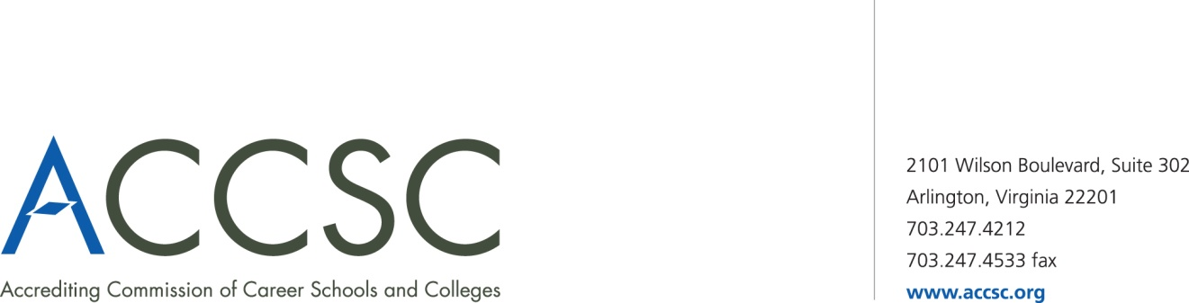NSTITUTIONAL DEVELOPMENT**

**PAYMENT SUBMISSION FORM FOR APPLICATION SUBMISSIONS**

|  |  |  |  |
| --- | --- | --- | --- |
| **SCHOOL #(s)** | **SCHOOL NAME(s)** | **CITY** | **STATE** |
|  |  |  |  |

|  |  |  |
| --- | --- | --- |
| **APPLICATION TYPE(s)** | **NAME OF PROGRAM(s)**  (*if applicable*) | **PAYMENT AMOUNT(s)**  (*Enter payment amount for each application type*) |
|  |  |  |

|  |  |
| --- | --- |
| **TOTAL PAYMENT AMOUNT** | **CHECK NUMBER** |
|  |  |

|  |  |  |  |
| --- | --- | --- | --- |
| **NAME OF CONTACT PERSON** | **TITLE** | **PHONE NUMBER** | **EMAIL** |
|  |  |  |  |

**\* Please submit a payment submission form with each check payment.**

**Submit To: Operations Department**

**Accrediting Commission of Career Schools and Colleges**

**2101 Wilson Boulevard, Suite 302**

**Arlington, VA 22201**