A distance education facility is a separate facility housing the functions associated with distance education delivery operations. The facility is an extension of a main school or branch campus that has distance education within the school’s scope of accreditation (Section VIII (A)(3), Substantive Standards, Standards of Accreditation). This application must be submitted no later than 30 days prior to the opening of the facility.

GUIDELINES FOR SUBMISSION - PLEASE REVEW PRIOR TO SUBMISSION:
1. The school must ensure that the Payment Submission Form of this application is included and identifies the correct fee amount, check information, and indicates the correct and applicable school(s).
2. The school must provide a response and all appropriate supporting documentation to all items below. The Commission may not process the application and may require a new submission from the school if the application is found to be incomplete.
3. The completed application should not exceed 100 pages total and should include only the required information. Do not provide copies of the school catalog or information that does not pertain to the items in this application.
4. Prior to final submission of this application, review the entire submission to ensure that all required information is provided, that all intended attachments are included, and that the submission is free of errors and typos.
ELECTRONIC SUBMISSION FORMAT REQUIREMENTS:
- Electronic Submissions may not be transmitted to the Commission via e-mail.
- The school’s response must be prepared in accordance with ACCSC’s Instructions for Electronic Submission (e.g., prepared as one Portable Document Format (“PDF”) file that has been prepared using Adobe Acrobat software (version 8.0 or higher) and which has a .pdf extension as part of the file name). The school will receive an e-mail confirmation that the file has been received within 24 hours of the submission.
- Please visit the ACCSC website for specific resources and guidance regarding how to successfully complete this application: Forms and Reports-Guidance/Sample Applications. ACCSC encourages the school to review this module prior to submitting this application.
- Additionally, do not copy and paste answers from previous applications.

I have read and understand the Guidelines for Submission and the Electronic Document Format Requirements set forth above and I further understand that a failure to adhere to these guidelines and requirements will result in either a delay in the processing of or return of this application.

Name | Signature | Title | Date

School # | School Name | Type |  | City | State
 |  | Main: | ☐
 |  | Branch: | ☐

Contact Person | Phone | Email

Street Address of  Distance Education Facility | city | state | zip code | Telephone Number | Proposed Start Date of Operation (month/day/year)

PLEASE ANSWER THE FOLLOWING QUESTIONS (Select One): | Yes | No
Is the ownership of the distance education facility identical to that of the main school or branch (i.e., owned by the same corporation or person(s))? If not, explain fully in an attachment to this application. | ☐ | ☐
Is the main school or branch subject to a Show Cause Order or Probation? A main school subject to a Show Cause Order or Probation may not apply for accreditation or recognition of any type of separate facility. | ☐ | ☐
Is the main school or branch subject to reporting for issues related to financial soundness, student achievement or adequacy of management? If yes, the school is required to seek and receive approval from the Commission in advance of submitting an application for a separate facility.  Please submit a Request to Show Good Cause prior to submitting the distance education facility application. | ☐ | ☐
Does the main school or branch have distance education in its approved scope of accreditation? | ☐ | ☐
I certify that the information herein and attached hereto is correct and that this non-degree program has not been described in the catalog, advertised or offered to students.
Name | Signature | Title | Date

Application Processing Fee
Please mail a check directly to ACCSC for processing and include a statement identifying the corresponding applications(s). Note: Please ensure that the Payment Submission Form for this application is included and identifies the corresponding application(s), fee amount, and check number.
- Processing Fee of $1500 per application.
Please note that should an application be deemed incomplete, the school will receive a request for additional information via email. If upon review of the additional information, the application is still incomplete, the school will receive a deferral letter requesting additional information and the school will be assessed a $150 application deferral fee for the submission of the additional information, which must be paid upon the submission of the additional information response.

Required Supporting Documentation
- Documentation of compliance with the state or appropriate regulatory agency for the addition of the proposed distance education facility.
- Documentation of compliance with local fire, safety and sanitation standards as required by appropriate regulatory authorities (e.g., occupancy permit).
- A copy of the executed lease agreement or purchase agreement accompanied by a sketch of the floor plan or building plan for the distance education facility.
- A detailed description of all functions and support services provided at the facility.
- An explanation of how the oversight school will maintain proper management, control, and supervision of the distance education facility.
- Provide a description of how the main school/branch allocate budget resources for the establishment of the proposed distance education facility in such areas as staff and faculty salaries, staff and faculty development, educational materials, learning resource materials, supplies/equipment, and advertising? Submit a copy of the proposed budget for the distance education facility.
- Provide a detailed description of how the main school/branch assesses and evaluates the distance education facility’s operations and incorporates the on-going assessment and improvement activities into its Institutional Assessment and Improvement Plan.
- A description of how the affiliation of the distance education facility to the main school/branch is identified in all institutional publications and advertising.

SUBMIT TO: Executive Director
Accrediting Commission of Career Schools and Colleges
2101 Wilson Boulevard / Suite 302
Arlington, Virginia 22201

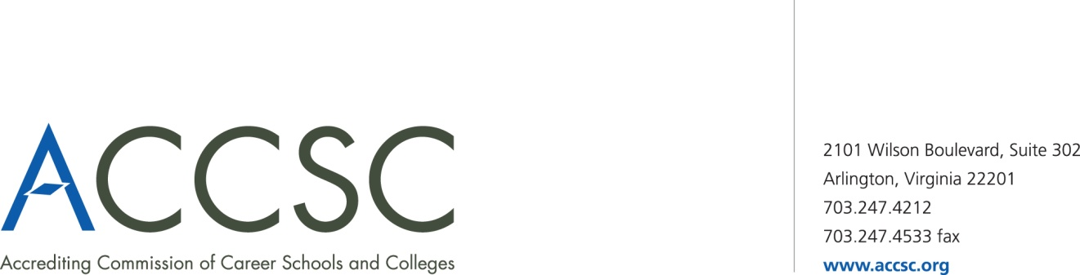
INSTITUTIONAL DEVELOPMENT: PAYMENT SUBMISSION FORM FOR APPLICATION SUBMISSIONS

School(s) # | School(s)  (Please list all schools applicable to payment) | City | State

Application Type(s)  *Please refer to attached list for application types | Payment Amount(s)  (Enter payment amount for each application type)

Total Payment Amount | Check Number

Name of contact person(s) | Title(s) | contact phone number(s) | contact email(s)

- Please submit this payment form with each check payment.

Submit To: Operations Department
Accrediting Commission of Career Schools and Colleges
2101 Wilson Boulevard, Suite 302
Arlington, VA 22201

*Application Type(s)

Application of Hours for Clock Hour Programs | Application for Continuing Education and Avocational Courses | Application for Approval of a Baccalaureate Degree
Application for Approval of an Academic Associates Degree | Application for Approval of a Master’s Degree | Application for Approval of an Occupational Associates Degree
Application for a Branch Part I | Application for a Branch Part II | Application for a Branch Realignment, Part I
Application for a Branch Realignment, Part II | Application for a Change of Location Part I | Application for a Change of Location Part I
Application for a Change of Name Part I | Application for a Change of Control Part I | Application for a Change of Control Part II
Application for Clock to Credit Hour Conversion | Application for a Distance Education Facility | Application for Initial Distance Education
Application for Expansion of Distance Education Approval | Application for a Change of Mission | Application for English as a Second Language Courses
Application for a Non-Degree Program | Application for a Satellite Location | Application for a Substantive Program Modification
Application for a Substantive Program Modification Addition of Concentration | Modification of Ownership Report | Consortium Partnership Report
Distance Education Consortium Partnership Agreement | Facility Expansion Report | Program Modification Report Non-substantive Modification
Application for a Baccalaureate Degree – Affiliated | Application for an Associate Degree – Affiliated | Application for a Non-Degree Program – Affiliated
Application for a Substantive Program Modification – Affiliated | Application for a Clock to Credit Hour Conversation – Affiliated | Program Modification – Non Substantive Modification – Affiliated
Application for use of “University” in the School Name Part – I | Application for use of “University” in the School Name Part – II | Application for a Change of Name Part II
Application of a Non-Degree Program with Expansion of Distance Education | Application for Approval of an Associate Degree Program with Expansion of Distance Education

