**To be submitted by the host institution in any instance where a school proposes to offer a portion of a program(s) by distance education through a consortium/partnership agreement with one or more affiliated, accredited institutions.**

**A school may not award more than 50% of the total number of clock or credit hours required in a program via a consortium, partnership, or contractual agreement (*Section II (A)(8)(b), Substantive Standards, Standards of Accreditation).***

**Note: Host institutions must have distance education in its scope of accreditation.**

|  |
| --- |
| **GUIDELINES FOR SUBMISSION**  1. The school must ensure that the **Payment Submission Form** of this application is included. Please ensure that the form lists the correct school, fee amount, and check information. If the school would like to submit payment via credit card, please contact the ACCSC office.  2. The school must provide a response to all items in this application, along with any relevant supporting documentation. Please do not copy and paste information from previous applications. If the application is deemed incomplete, the Commission may determine that a new submission is needed prior to review.  3. The completed application should include only the required information and not exceed **100 pages**. Unless specifically requested, do not provide copies of the full school catalog or information that does not pertain to the items in this application.  4. Please review the application prior to final submission to ensure that all required information is provided, that all intended attachments are included, and that the submission is free of errors and typos. |

|  |
| --- |
| **ELECTRONIC SUBMISSION FORMAT REQUIREMENTS**   * Electronic Submissions submitted via e-mail will not be processed. Please upload all submissions to the ACCSC College360 database. The school will receive an e-mail confirmation that the file has been received within 24 hours of the submission. * The school’s response must be prepared in accordance with ACCSC’s Instructions for Electronic Submission (e.g., prepared as one continuous PDF document with the required bookmarks). * Please visit the ACCSC website for specific resources and guidance regarding how to successfully complete and submit this application. |

**I have read and understand the Guidelines for Submission and the Electronic Document Format Requirements set forth above and I further understand that a failure to adhere to these guidelines and requirements will result in either a delay in the processing of or return of this application.**

**I certify that the information herein and attached hereto is correct.**

|  |  |  |  |
| --- | --- | --- | --- |
| **Name** | **Signature** | **Title** | **Date** |
|  |  |  |  |

|  |  |  |
| --- | --- | --- |
| **Contact Person** | **Phone** | **Email** |
|  |  |  |

**List all schools below that will participate in the agreement and that will share courses. Indicate the Host institution(s) and the Home institution(s) as applicable (the Host institution will be the provider of the online courses to the home institution(s)).**

|  |  |  |  |  |  |  |
| --- | --- | --- | --- | --- | --- | --- |
| **School #** | **School Name** | **Type** | | **City** | **State** | **host* or home** |
|  |  | Main: |  |  |  | Choose an item. |
| Branch: |  |
|  |  | Main: |  |  |  | Choose an item. |
| Branch: |  |
|  |  | Main: |  |  |  | Choose an item. |
| Branch: |  |
|  |  | Main: |  |  |  | Choose an item. |
| Branch: |  |

* Host institution offers the program/course to students from the Home institutions

|  |  |  |
| --- | --- | --- |
| **List Proposed Program Title, Credential, and Course(s) [1]** | | |
| **Program Name (Credential)** | **Technical Course Title(s)** | **General Education Courses Title(s)** |
| ***Business Administration (BS)*** | ***ECON101: Intro to Economics***  ***MKT101: Intro to Marketing*** | ***N/A*** |
| ***General Education Courses  (All Programs)*** | ***N/A*** | ***ENG101: English Composition***  ***COMM101: Speech***  ***Math101: College Algebra*** |
|  |  |  |

|  |  |  |
| --- | --- | --- |
| **Existing Consortium Programs Title, Credential, and Course(s)[2]** | | |
| **Program Name (Credential)** | **Technical Course Title(s)** | **General Education Courses Title(s)** |
|  |  |  |
|  |  |  |
|  |  |  |

|  |
| --- |
| **Application Processing Fee**  Please submit payment to ACCSC for processing and include a statement identifying the corresponding applications(s). **Note**: Please ensure that the **Payment Submission Form** for this application is included and identifies the corresponding application(s), fee amount, and check number.   * Application for Distance Education Consortium/Partnership Agreement: **$1,500**   Please note that should an application be deemed incomplete, the school will receive a request for additional information via email. If upon review of the additional information, the application is still incomplete, the school will be assessed a **$250** additional information processing fee for the submission of the additional information, which must be paid upon submission of the response.  **Incorrect Application Fee**  Please ensure that the school is utilizing the correct application. Upon review of the application, if determined that the school should have utilized a different application, a **$250** Incorrect Application Fee will be assessed |

**Required Supporting Documentation**

**Host Institution:**

1. If the Host institution is **not** an ACCSC accredited institution, please provide documentation of the institution’s accredited status and its approval to offer programs and/or courses via distance education.
2. Provide documentation that the Host institution is authorized, if required, to deliver distance education programs/courses to students in the states where the Home institution(s) is/are located.
3. Provide ACCSC approval and any other applicable accreditor approval required for Host institution to offer these programs via distance education.
4. Describe the educational administration structure for the Host institution assuring proper oversight of the proposed consortium/partnership arrangement.
5. Provide a final copy of the consortium/ agreement signed and dated by all applicable parties.

**Home Institution:**

The Home institution retains responsibility for the quality of the courses of study and programs offered, as well as the achievement of expected and acceptable outcomes, irrespective of any consortium, partnership, or contractual arrangement entered into with a third party in order to provide any portion of a program or course of study.

For each Home institution, please provide the following:

1. An attestation that the Home institution(s) understand the responsibilities outlined above.
2. Explain how the school will assess the student’s technical skills, competencies, and access to technology as well as if the student’s learning style is conducive to online learning **prior** to their enrollment in the program or course of study (*Section IX (F)(2)(a-b), Substantive Standards, Standards of Accreditation*).
3. Provide a copy of the assessment tool(s) and an explanation regarding how the school determined the appropriateness of the assessment tool selected by the school (*Section IX (F)(3), Substantive Standards, Standards of Accreditation*).
4. Provide the name, title, and experience of the Home institution’s distance education PAC member(s) qualifying their ability to adequately review and comment on the school’s distance education platform, methods, processes, procedures, and infrastructure in the context of the program/course content and objectives

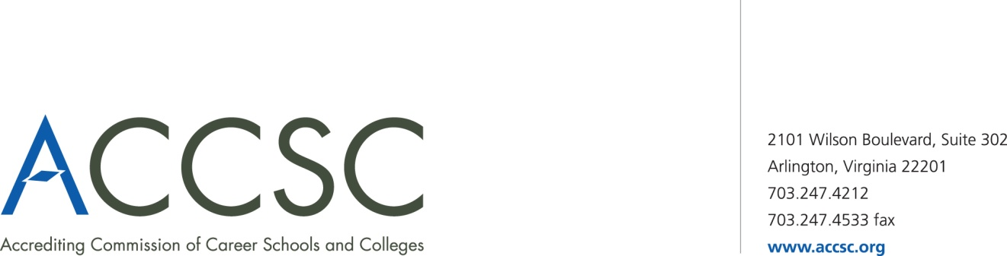**INSTITUTIONAL DEVELOPMENT**

**PAYMENT SUBMISSION FORM FOR APPLICATION SUBMISSIONS**

|  |  |  |  |
| --- | --- | --- | --- |
| **SCHOOL #(s)** | **SCHOOL NAME(s)** | **CITY** | **STATE** |
|  |  |  |  |

|  |  |  |
| --- | --- | --- |
| **APPLICATION TYPE(s)** | **NAME OF PROGRAM(s)**  (*if applicable*) | **PAYMENT AMOUNT(s)**  (*Enter payment amount for each application type*) |
|  |  |  |

|  |  |
| --- | --- |
| **TOTAL PAYMENT AMOUNT** | **CHECK NUMBER** |
|  |  |

|  |  |  |  |
| --- | --- | --- | --- |
| **NAME OF CONTACT PERSON** | **TITLE** | **PHONE NUMBER** | **EMAIL** |
|  |  |  |  |

**\* Please submit a payment submission form with each check payment.**

**Submit To: Operations Department**

**Accrediting Commission of Career Schools and Colleges**

**2101 Wilson Boulevard, Suite 302**

**Arlington, VA 22201**

1. Programs and/or courses offered through this Distance Education Consortium must be approved and offered at both institutions, Host and Home.
2. Provide a list of all current programs/courses approved through previous distance education consortium agreements.