To be submitted by the host institution in any instance where a school proposes to offer a portion of a program(s) via distance education through a consortium/partnership agreement with one or more affiliated, accredited institutions.
Note: All institutions must have distance education delivery in their scope of accreditation.
GUIDELINES FOR SUBMISSION
1. The school must ensure that the Payment Submission Form of this application is included. Please ensure that the form lists the correct school, fee amount, and check information. If the school would like to submit payment via credit card, please contact the ACCSC office.
2. The school must provide a response to all items in this application, along with any relevant supporting documentation. Please do not copy and paste information from previous applications. If the application is deemed incomplete, the Commission may determine that a new submission is needed prior to review.
3. The completed application should include only the required information and not exceed 100 pages. Unless specifically requested, do not provide copies of the full school catalog or information that does not pertain to the items in this application.
4. Please review the application prior to final submission to ensure that all required information is provided, that all intended attachments are included, and that the submission is free of errors and typos.

ELECTRONIC SUBMISSION FORMAT REQUIREMENTS
- Electronic Submissions submitted via e-mail will not be processed. Please upload all submissions to the ACCSC College360 database. The school will receive an e-mail confirmation that the file has been received within 24 hours of the submission.
- The school’s response must be prepared in accordance with ACCSC’s Instructions for Electronic Submission (e.g., prepared as one continuous PDF document with the required bookmarks).
- Please visit the ACCSC website for specific resources and guidance regarding how to successfully complete and submit this application.

I have read and understand the Guidelines for Submission and the Electronic Document Format Requirements set forth above and I further understand that a failure to adhere to these guidelines and requirements will result in either a delay in the processing of or return of this application.

I certify that the information herein and attached hereto is correct.

Name | Title | Email
Signature |  |  | Date

Contact Person | Phone | Email
List all schools below that will participate in the agreement and that will share courses. Indicate the Host institution(s) and the Home institution(s) as applicable (the Host institution will be the provider of the online courses to the home institution(s).

School # | School Name | Type |  | City | State | host* or home
 |  | Main: | ☐ |  |  | Choose an item.
 |  | Branch: | ☐ |  |  | Choose an item.
 |  | Main: | ☐ |  |  | Choose an item.
 |  | Branch: | ☐ |  |  | Choose an item.
 |  | Main: | ☐ |  |  | Choose an item.
 |  | Branch: | ☐ |  |  | Choose an item.
 |  | Main: | ☐ |  |  | Choose an item.
 |  | Branch: | ☐ |  |  | Choose an item.

List Proposed Program Title, Credential, and Course(s)
Program Name (Credential) | Percentage of Program via DE Consortium | Technical Course Title(s) | General Education Courses Title(s)
Medical Assisting (Certificate)) | 20% | MA101: Medical Ethics  MA102: Patient Care | N/A
Business Administration (AS) | 10% | N/A | ENG101: English Composition  COMM101: Speech  Math101: College Algebra

Existing Consortium Programs Title, Credential, and Course(s)
Program Name (Credential) | Technical Course Title(s) | General Education Courses Title(s)

Application Processing Fee
Please submit payment to ACCSC for processing and include a statement identifying the corresponding applications(s). Note: Please ensure that the Payment Submission Form for this application is included and identifies the corresponding application(s), fee amount, and check number.
- Application for Distance Education Consortium/Partnership Agreement: $2,000

Please note that should an application be deemed incomplete, the school will receive a request for additional information via email. If upon review of the additional information, the application is still incomplete, the school will be assessed a $250 additional information processing fee for the submission of the additional information, which must be paid upon submission of the response.
Incorrect Application Fee
Please ensure that the school is utilizing the correct application. Upon review of the application, if determined that the school should have utilized a different application, a $250 Incorrect Application Fee will be assessed
Required Supporting Documentation
Host Institution:
- If the Host institution is not an ACCSC accredited institution, please provide documentation of the institution’s accredited status and its approval to offer programs and/or courses via distance education.
- Provide documentation that the Host institution is authorized, if required, to deliver distance education programs/courses to students in the states where the Home institution(s) is/are located.
- Provide ACCSC approval and any other applicable accreditor approval required for Host institution to offer these programs via distance education.
- Describe the educational administration structure for the Host institution assuring proper oversight of the proposed consortium/partnership arrangement.
- Provide a final copy of the consortium/ agreement signed and dated by all applicable parties.

Home Institution:
The Home institution retains responsibility for the quality of the courses of study and programs offered, as well as the achievement of expected and acceptable outcomes, irrespective of any consortium, or partnership arrangement entered into with a third party in order to provide any portion of a program or course of study.

For each Home institution, please provide the following:
- An attestation that the Home institution(s) understand the responsibilities outlined above.
- Provide the school’s process and procedure for how the school will review an applicant’s access and technical readiness relative to the school’s specific distance education platform/environment prior to their enrollment in the program or course of study (Section V (A)(4), Substantive Standards, Standards of Accreditation).
- If the school utilizes an assessment tool for admission into the distance education program, provide a copy of the assessment tool and an explanation of how the tool will aid in admissions decision (e.g., passing score, remediation, etc.).
- Provide the name, title, and experience of the Home institution’s distance education PAC member(s) qualifying their ability to adequately review and comment on the school’s distance education platform, methods, processes, procedures, and infrastructure in the context of the program/course content and objectives

INSTITUTIONAL DEVELOPMENT
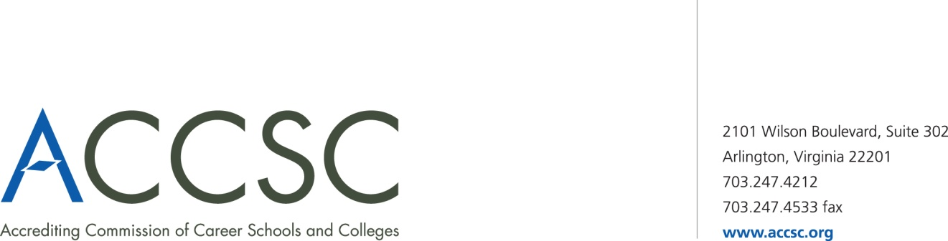
PAYMENT SUBMISSION FORM FOR APPLICATION SUBMISSIONS

Please submit a copy of this form with both the application and check payment. Applications will not be processed until payment has been received.

SCHOOL #(s) | SCHOOL NAME(s) | CITY | STATE

APPLICATION TYPE(s) | NAME OF PROGRAM(s)  (if applicable) | PAYMENT AMOUNT(s)  (Enter payment amount for each application type)

TOTAL PAYMENT AMOUNT | CHECK NUMBER

NAME OF CONTACT PERSON | TITLE | PHONE NUMBER | EMAIL

Submit To: Operations Department
Accrediting Commission of Career Schools and Colleges
2101 Wilson Boulevard, Suite 302
Arlington, VA 22201

Programs and/or courses offered through this Distance Education Consortium must be approved and offered at both institutions, Host and Home.
Any program where 50% or more of the total number of clock or credit hours is offered via a consortium/partnership requires review and approval by the Commission. In all instances a school may not award more than 75% of the total number of clock or credit hours required in a program via a consortium or partnership (Section II (A)(8)(b), Substantive Standards, Standards of Accreditation). Additionally, if the school chooses to utilize the more than 50% option it may impact the financial aid eligibility for that program.
Provide a list of all current programs/courses approved through previous distance education consortium agreements.

