**To be submitted at least 30 days prior to awarding credit hours in any program and/or with appropriate applications/reports (*Section IV (E)(6)(a)(vii), Rules of Process and Procedure, Standards of Accreditation*).**

|  |
| --- |
| **GUIDELINES FOR SUBMISSION**   * The school must ensure that the provided **Institutional Development** **Payment Submission Form** is included with the submission. Please ensure that the form lists the correct school name, fee amount, and check information. If the school would like to submit payment via credit card, please contact the ACCSC office. * The school must provide a response to all items in this application, along with any relevant supporting documentation. Please do not copy and paste information from previous applications. If the application is deemed incomplete, the Commission may determine that a new submission is needed prior to review. * The completed application should include only the required information and not exceed **100 pages**. Unless specifically requested, do not provide copies of the full school catalog or information that does not pertain to the items in this application. * Please review the application prior to final submission to ensure that all required information is provided, that all intended attachments are included, and that the submission is free of errors and typos. * Incorrect application submissions will incur a $250 Incorrect Application Fee. |

|  |
| --- |
| **ELECTRONIC SUBMISSION FORMAT REQUIREMENTS**   * Electronic Submissions submitted via e-mail will not be processed. Please upload all submissions to the ACCSC College360 database. The school will receive an e-mail confirmation that the file has been received within 24 hours of the submission. * The school’s response must be prepared in accordance with ACCSC’s Instructions for Electronic Submission (e.g., prepared as one continuous PDF document with the required bookmarks). * Please visit the ACCSC website for specific resources and guidance regarding how to successfully complete and submit this application. |

I certify the school utilized thoroughly developed credit hour award rationales in accordance with ACCSC’s *Definition of a Credit Hour – Appendix III, Standards of Accreditation*.

I certify the school complies with applicable state and federal regulations related to clock-to-credit hour conversions (*Section I (D)(4)(b), Rules of Process and Procedure, Standards of Accreditation*).

I certify that the information herein and attached hereto is correct and that the school has not awarded credit hours in the program(s) represented in this application prior to receiving Commission approval.

**I have read and understand the Guidelines for Submission and the Electronic Submission Format Requirements set forth above and I further understand that a failure to adhere to these guidelines and requirements will result in either a delay in the processing of or return of this application.**

|  |  |  |  |
| --- | --- | --- | --- |
| **Name** | **Signature** | **Title** | **Date** |
|  |  |  |  |

|  |  |  |  |  |  |  |  |
| --- | --- | --- | --- | --- | --- | --- | --- |
| **School #** | **School Name** | **Type** | | **City** | **State** | **Degree Granting** | |
|  |  | Main: |  |  |  | YES |  |
| Branch: |  | NO |  |

|  |  |  |
| --- | --- | --- |
| **Contact Person** | **Phone** | **Email** |
|  |  |  |

**Program Information Prior to the Modification[1]:**

|  |  |  |
| --- | --- | --- |
| **Program Title**  *(e.g. Business Administration)* | **Instructional Clock Hours** | **Full Credential & Abbreviation** |
|  |  |  |
|

**Program Information After the Modification:**

|  |  |  |  |  |  |  |
| --- | --- | --- | --- | --- | --- | --- |
| **Program Title**  *(e.g. Business Administration)* | **Instructional Clock Hours** | **Total Clock Hours & Outside Prep Hours** | **Total Credit Hours** | **Type of Credit Hours** | | **Full Credential & Abbreviation** |
|  |  |  |  | Semester: |  |  |
| Quarter: |  |

|  |
| --- |
| **Application Processing Fee**  Please submit payment to ACCSC for processing and include a statement identifying the corresponding applications(s). **Note**: Please ensure that the **Payment Submission Form** for this application is included and identifies the corresponding application(s), fee amount, and check number.   * Type of Application: **$500**   Please note that should an application be deemed incomplete, the school will receive a request for additional information via email. If upon review of the additional information, the application is still incomplete, the school will be assessed a **$250** additional information processing fee for the submission of the additional information, which must be paid upon submission of the response.  **Incorrect Application Fee**  Please ensure that the school is utilizing the correct application. Upon review of the application, if determined that the school should have utilized a different application, a **$250** Incorrect Application Fee will be assessed. |

**Required Supporting Documentation**

1. Provide program approval from the state (or applicable regulatory agency) with the title and approved clock and credit hours. If the school requires Commission approval prior to state approval, please provide documentation demonstrating the school is currently recognized by the state.
2. An **Outline of a Non-Degree Program**, demonstrating compliance with *Section II (A) (3)(b), Substantive Standards, Standards of Accreditation*.
3. Provide a narrative describing the institutional processes and procedures used to determine the average amount of time expected for out-of-class work/preparation (Note: ACCSC requires that for programs to be recognized in credit hours, the program must be comprised of a majority of courses that require out-of-class work/preparation (*Section II (A)(3)(f), Substantive Standards, Standards of Accreditation*).
4. Provide sample course syllabi for one technical course **and** if applicable,one general education course, demonstrating outside preparation that the school would like recognized by the Commission. Outside preparation may include the following: assignments such as reading assignments, writing assignments, practice and practical application, and projects or other equivalent learning experiences that may be assessed/graded, etc.

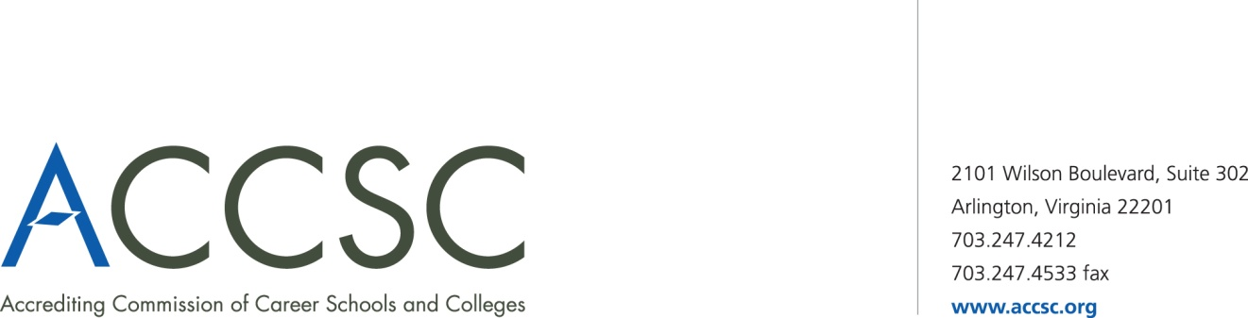**INSTITUTIONAL DEVELOPMENT**

**PAYMENT SUBMISSION FORM FOR APPLICATION SUBMISSIONS**

|  |  |  |  |
| --- | --- | --- | --- |
| **SCHOOL #(s)** | **SCHOOL NAME(s)** | **CITY** | **STATE** |
|  |  |  |  |

|  |  |  |
| --- | --- | --- |
| **APPLICATION TYPE(s)** | **NAME OF PROGRAM(s)**  (*if applicable*) | **PAYMENT AMOUNT(s)**  (*Enter payment amount for each application type*) |
|  |  |  |

|  |  |
| --- | --- |
| **TOTAL PAYMENT AMOUNT** | **CHECK NUMBER** |
|  |  |

|  |  |  |  |
| --- | --- | --- | --- |
| **NAME OF CONTACT PERSON** | **TITLE** | **PHONE NUMBER** | **EMAIL** |
|  |  |  |  |

**\* Please submit a payment submission form with each check payment.**

**Submit To: Operations Department**

**Accrediting Commission of Career Schools and Colleges**

**2101 Wilson Boulevard, Suite 302**

**Arlington, VA 22201**

1. Only one program may be included in each application.