To be submitted at least 30 days prior to awarding credit hours in any program and/or with appropriate applications/reports (Section IV (E)(6)(a)(vii), Rules of Process and Procedure, Standards of Accreditation).

GUIDELINES FOR SUBMISSION - PLEASE REVEW PRIOR TO SUBMISSION:
1. The school must ensure that the Payment Submission Form of this application is included and identifies the correct fee amount, check information, and indicates the correct and applicable school(s).
2. The school must provide a response and all appropriate supporting documentation to all items below. The Commission may not process the application and may require a new submission from the school if the application is found to be incomplete.
3. The completed application should not exceed 100 pages total and should include only the required information. Do not provide copies of the school catalog or information that does not pertain to the items in this application.
4. Prior to final submission of this application, review the entire submission to ensure that all required information is provided, that all intended attachments are included, and that the submission is free of errors and typos.
ELECTRONIC SUBMISSION FORMAT REQUIREMENTS:
- Electronic Submissions may not be transmitted to the Commission via e-mail.
- The school’s response must be prepared in accordance with ACCSC’s Instructions for Electronic Submission (e.g., prepared as one Portable Document Format (“PDF”) file that has been prepared using Adobe Acrobat software (version 8.0 or higher) and which has a .pdf extension as part of the file name). The school will receive an e-mail confirmation that the file has been received within 24 hours of the submission.
- Please visit the ACCSC website for specific resources and guidance regarding how to successfully complete this application: Forms and Reports-Guidance/Sample Applications. ACCSC encourages the school to review this module prior to submitting this application.
- Additionally, do not copy and paste answers from previous applications.

I certify the school utilized thoroughly developed credit hour award rationales in accordance with ACCSC’s Definition of a Credit Hour – Appendix III, Standards of Accreditation.
I certify the school complies with applicable state and federal regulation related to clock-to-credit hour conversions (Section I (D)(4)(b), Rules of Process and Procedure, Standards of Accreditation).
I certify that the information herein and attached hereto is correct and that the school has not awarded credit hours in the program(s) represented in this application prior to receiving Commission approval.
Name | Signature | Title | Date

School # | School Name | Type |  | City | State | Degree Granting
 |  | Main: | ☐ |  |  | Yes: | ☐
 |  | Branch: | ☐ |  |  | No: | ☐

Contact Person | Phone | Email

1. PROGRAM INFORMATION PRIOR TO THE CHANGE:

Program Title  (e.g. Business Administration) | Instructional Clock Hours | Full Credential & Abbreviation

2. PROGRAM INFORMATION AFTER THE CHANGE:

Program Title  (e.g. Business Administration) | Instructional Clock Hours | Total Clock Hours & Outside Prep Hours | Total Credit Hours | Type of Credit Hours |  | Full Credential & Abbreviation
 |  |  |  | Semester: | ☐
 |  |  |  | Quarter: | ☐
Application Processing Fee
Please mail a check directly to ACCSC for processing and include a statement identifying the corresponding applications(s). Note: Please ensure that the Payment Submission Form for this application is included and identifies the corresponding application(s), fee amount, and check number.
- Processing Fee of $500 per application.
Please note that should an application be deemed incomplete, the school will receive a request for additional information via email. If upon review of the additional information, the application is still incomplete, the school will receive a deferral letter requesting additional information and the school will be assessed a $150 application deferral fee for the submission of the additional information, which must be paid upon the submission of the additional information response.

Required Supporting Documentation
- Provide program approval from the state (or applicable regulatory agency) with the title and approved clock and credit hours. If the school requires Commission approval prior to state approval, please provide documentation demonstrating the school is currently recognized by the state.
- An Outline of a Degree Program or an Outline of a Non-Degree Program, as applicable, for each program, demonstrating compliance with Section II (3)(b), Substantive Standards, Standards of Accreditation.
- Narrative describing the institutional processes and procedures used to determine the average amount of time expected for out-of-class work/preparation (Note: ACCSC requires that for programs to be recognized in credit hours, the program must be comprised of a majority of courses that require out-of-class work/preparation (Section II (A)(3)(f), Substantive Standards, Standards of Accreditation).
- Sample course syllabi for one technical course and if applicable one general education course, per program demonstrating outside preparation that the school would like recognized by the Commission. Outside preparation may include the following: assignments with specific requirements such as reading assignments, writing assignments, practice and practical application, and projects or other equivalent learning experiences that may be assessed/graded.

SUBMIT TO: Executive Director
Accrediting Commission of Career Schools and Colleges
2101 Wilson Boulevard / Suite 302
Arlington, Virginia 22201

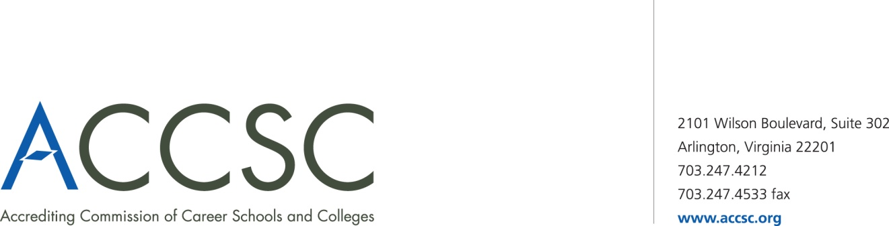
INSTITUTIONAL DEVELOPMENT: PAYMENT
SUBMISSION FORM FOR APPLICATION SUBMISSIONS

School(s) # | School(s)  (Please list all schools applicable to payment) | City | State

Application Type(s)  *Please refer to attached list for application types | Payment Amount(s)  (Enter payment amount for each application type)

Total Payment Amount | Check Number

Name of contact person(s) | Title(s) | contact phone number(s) | contact email(s)

- Please submit this payment form with each check payment.

Submit To: Operations Department
Accrediting Commission of Career Schools and Colleges
2101 Wilson Boulevard, Suite 302
Arlington, VA 22201

*Application Type(s)

Application of Hours for Clock Hour Programs | Application for Continuing Education and Avocational Courses | Application for Approval of a Baccalaureate Degree
Application for Approval of an Academic Associates Degree | Application for Approval of a Master’s Degree | Application for Approval of an Occupational Associates Degree
Application for a Branch Part I | Application for a Branch Part II | Application for a Branch Realignment, Part I
Application for a Branch Realignment, Part II | Application for a Change of Location Part I | Application for a Change of Location Part I
Application for a Change of Name Part I | Application for a Change of Control Part I | Application for a Change of Control Part II
Application for Clock to Credit Hour Conversion | Application for a Distance Education Facility | Application for Initial Distance Education
Application for Expansion of Distance Education Approval | Application for a Change of Mission | Application for English as a Second Language Courses
Application for a Non-Degree Program | Application for a Satellite Location | Application for a Substantive Program Modification
Application for a Substantive Program Modification Addition of Concentration | Modification of Ownership Report | Consortium Partnership Report
Distance Education Consortium Partnership Agreement | Facility Expansion Report | Program Modification Report Non-substantive Modification
Application for a Baccalaureate Degree – Affiliated | Application for an Associate Degree – Affiliated | Application for a Non-Degree Program – Affiliated
Application for a Substantive Program Modification – Affiliated | Application for a Clock to Credit Hour Conversation – Affiliated | Program Modification – Non Substantive Modification – Affiliated
Application for use of “University” in the School Name Part – I | Application for use of “University” in the School Name Part – II | Application for a Change of Name Part II
Application for a Non-Degree Program with Expansion of Distance Education | Application for Approval of an Associate Degree Program with Expansion of Distance Education

