**To be submitted within 30 days after the school receives the state license showing the new name (*Section IV (E)(3)(a)(ii), Rules of Process and Procedure, Standards of Accreditation*).**

|  |
| --- |
| **GUIDELINES FOR SUBMISSION**   * The school must ensure that the provided **Institutional Development** **Payment Submission Form** is included with the submission. Please ensure that the form lists the correct school name, fee amount, and check information. If the school would like to submit payment via credit card, please contact the ACCSC office. * The school must provide a response to all items in this application, along with any relevant supporting documentation. Please do not copy and paste information from previous applications. If the application is deemed incomplete, the Commission may determine that a new submission is needed prior to review. * The completed application should include only the required information and not exceed **100 pages**. Unless specifically requested, do not provide copies of the full school catalog or information that does not pertain to the items in this application. * Please review the application prior to final submission to ensure that all required information is provided, that all intended attachments are included, and that the submission is free of errors and typos. * Incorrect application submissions will incur a $250 Incorrect Application Fee. |

|  |
| --- |
| **ELECTRONIC SUBMISSION FORMAT REQUIREMENTS**   * Electronic Submissions submitted via e-mail will not be processed. Please upload all submissions to the ACCSC College360 database. The school will receive an e-mail confirmation that the file has been received within 24 hours of the submission. * The school’s response must be prepared in accordance with ACCSC’s Instructions for Electronic Submission (e.g., prepared as one continuous PDF document with the required bookmarks). * Please visit the ACCSC website for specific resources and guidance regarding how to successfully complete and submit this application. |

**I have read and understand the Guidelines for Submission and the Electronic Document Format Requirements set forth above and I further understand that a failure to adhere to these guidelines and requirements will result in either a delay in the processing of or return of this application.**

**I certify that the information herein and attached hereto is correct.**

|  |  |  |  |
| --- | --- | --- | --- |
| **Name** | **Signature** | **Title** | **Date** |
|  |  |  |  |

|  |  |  |  |  |  |  |  |
| --- | --- | --- | --- | --- | --- | --- | --- |
| **School #** | **School Name** | **Type** | | **City** | **State** | **Degree Granting** | |
|  |  | Main: |  |  |  | Yes: |  |
| Branch: |  | No: |  |

|  |  |  |
| --- | --- | --- |
| **Contact Person** | **Phone** | **Email** |
|  |  |  |

|  |  |
| --- | --- |
| **New Name of School\*** | **Effective Date of Change**  *(month/day/year)* |
|  |  |

***\* Approved satellite location(s), if applicable and as noted in the Part I, will be included in the change of name approval***

|  |
| --- |
| **Application Processing Fee**  Please mail a check directly to ACCSC for processing and include a statement identifying the corresponding applications(s). **Note**: Please ensure that the **Payment Submission Form** for this application is included and identifies the corresponding application(s), fee amount, and check number.   * Application for a Change of Name-Part II: **$250**   Please note that should an application be deemed incomplete, the school will receive a request for additional information via email. If upon review of the additional information, the application is still incomplete, the school will be assessed a $250 additional information processing fee for the submission of the additional information, which must be paid upon the submission of the response.  **Incorrect Application Fee**  Please ensure that the school is utilizing the correct application. Upon review of the application, if determined that the school should have utilized a different application, a $250 Incorrect Application Fee will be assessed. |

**Required Supporting Documents**

* 1. Copy of the school’s state license and/or approval letter displaying the new name.
  2. The school’s revised school catalog, cross-referenced with the Catalog Checklist, using the new name.
  3. The school’s revised school enrollment agreement, cross-referenced with the Enrollment Agreement Checklist, using the new name.
  4. Copy of the school’s current advertising using the new name.

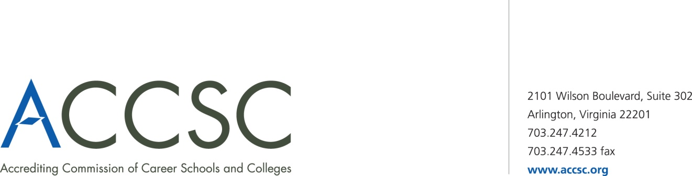**INSTITUTIONAL DEVELOPMENT**

**PAYMENT SUBMISSION FORM FOR APPLICATION SUBMISSIONS**

|  |  |  |  |
| --- | --- | --- | --- |
| **SCHOOL #(s)** | **SCHOOL NAME(s)** | **CITY** | **STATE** |
|  |  |  |  |

|  |  |  |
| --- | --- | --- |
| **APPLICATION TYPE(s)** | **NAME OF PROGRAM(s)**  (*if applicable*) | **PAYMENT AMOUNT(s)**  (*Enter payment amount for each application type*) |
|  |  |  |

|  |  |
| --- | --- |
| **TOTAL PAYMENT AMOUNT** | **CHECK NUMBER** |
|  |  |

|  |  |  |  |
| --- | --- | --- | --- |
| **NAME OF CONTACT PERSON** | **TITLE** | **PHONE NUMBER** | **EMAIL** |
|  |  |  |  |

**\* Please submit a payment submission form with each check payment.**

**Submit To: Operations Department**

**Accrediting Commission of Career Schools and Colleges**

**2101 Wilson Boulevard, Suite 302**

**Arlington, VA 22201**