**To be submitted in advance of a change in the mission or educational objectives of the school (*Section IV (E)(1), Rules of Process and Procedure, Standards of Accreditation*)*.* When planning to undertake a change of mission or educational objectives, please review the list of the substantive changes that would require a total re-evaluation under *Section IV (D)(9), Rules of Process and Procedure, Standards of Accreditation.***

|  |
| --- |
| **GUIDELINES FOR SUBMISSION**  1. The school must ensure that the **Payment Submission Form** of this application is included. Please ensure that the form lists the correct school, fee amount, and check information. If the school would like to submit payment via credit card, please contact the ACCSC office.  2. The school must provide a response to all items in this application, along with any relevant supporting documentation. Please do not copy and paste information from previous applications. If the application is deemed incomplete, the Commission may determine that a new submission is needed prior to review.  3. The completed application should include only the required information and not exceed **100 pages**. Unless specifically requested, do not provide copies of the full school catalog or information that does not pertain to the items in this application.  4. Please review the application prior to final submission to ensure that all required information is provided, that all intended attachments are included, and that the submission is free of errors and typos. |

|  |
| --- |
| **ELECTRONIC SUBMISSION FORMAT REQUIREMENTS**   * Electronic Submissions submitted via e-mail will not be processed. Please upload all submissions to the ACCSC College360 database. The school will receive an e-mail confirmation that the file has been received within 24 hours of the submission. * The school’s response must be prepared in accordance with ACCSC’s Instructions for Electronic Submission (e.g., prepared as one continuous PDF document with the required bookmarks). * Please visit the ACCSC website for specific resources and guidance regarding how to successfully complete and submit this application. |

**I have read and understand the Guidelines for Submission and the Electronic Document Format Requirements set forth above and I further understand that a failure to adhere to these guidelines and requirements will result in either a delay in the processing of or return of this application.**

**I certify that the information herein and attached hereto is correct.**

|  |  |  |  |
| --- | --- | --- | --- |
| **Name** | **Signature** | **Title** | **Date** |
|  |  |  |  |

**The Commission encourages schools to review continuously their institutional mission and educational objectives and to modify these as necessary for the effective delivery of the school’s educational program.**

**This application is for those instances where the change of the school’s Mission or Educational Objectives reflects a substantive change in the institution due to the cumulative effect of other substantive changes.**

|  |  |  |  |  |  |
| --- | --- | --- | --- | --- | --- |
| **School #** | **School Name** | **Type** | | **City** | **State** |
|  |  | Main: |  |  |  |
| Branch: |  |

|  |  |  |
| --- | --- | --- |
| **Contact Person** | **Phone** | **Email** |
|  |  |  |

|  |  |
| --- | --- |
| **Other Applications Currently Under Review:** | |
|  | Change of Control/Modification of Ownership |
|  | Change of Location |
|  | Change of Name |
|  | Application for New Non-Degree Program(s) |
|  | Application for New Degree Program(s) |
|  | Additional Facility (Branch/Satellite) |
|  | Increase in Credential Level |
|  | Other: |

**I certify that the information herein and attached hereto is correct.**

|  |  |  |  |
| --- | --- | --- | --- |
| **Name** | **Signature** | **Title** | **Date** |
|  |  |  |  |

|  |
| --- |
| **Application Processing Fee**  Please mail a check directly to ACCSC for processing and include a statement identifying the corresponding applications(s). **Note**: Please ensure that the **Payment Submission Form** for this application is included and identifies the corresponding application(s), fee amount, and check number.   * Application for a Change of Mission / Educational Objectives: **$1000**.   Please note that should an application be deemed incomplete, the school will receive a request for additional information via email. If upon review of the additional information, the application is still incomplete, the school will be assessed a $250 additional information processing fee for the submission of the additional information, which must be paid upon the submission of the response.  **Incorrect Application Fee**  Please ensure that the school is utilizing the correct application. Upon review of the application, if determined that the school should have utilized a different application, a $250 Incorrect Application Fee will be assessed. |

**Required Supporting Documents**

1. Provide approval from the state (or applicable regulatory agency). If the school requires Commission approval prior to state approval, please provide documentation demonstrating the school is currently recognized by the state.
2. Provide an assessment of need as to why the school is seeking to change its mission or educational objectives.
3. Provide a comprehensive and detailed description of the changes the institution plans to undertake as it changes its mission and educational objectives. Please include any substantive changes such as change of location, change of ownership, facility changes, program changes, etc.
4. Provide a revised institutional assessment plan and/or strategic plan which describe the school’s strategies and timelines for implementing the Change of Mission/Educational Objectives and any other related changes such as new programs, changes of location or facilities, etc.
5. Describe the impact that the proposed change of the mission or educational objectives may have on the current program curricula offered at the school. Please also describe how the school plans to maintain compliance with accrediting standards in relation to the program offerings at the school.
6. Submit a description of the impact, if any, of the proposed changes to the mission or educational objectives on the school’s name or advertising. If such changes warrant the submission of a substantive change application (i.e. Change of Name), please indicate the status of that application.
7. Provide a copy of the minutes from meetings held by the board of directors or other governing body in which the proposed changes were discussed.
8. If the school has a separate facility such as a satellite or branch campus, describe the impact of the proposed changes on the separate facility.

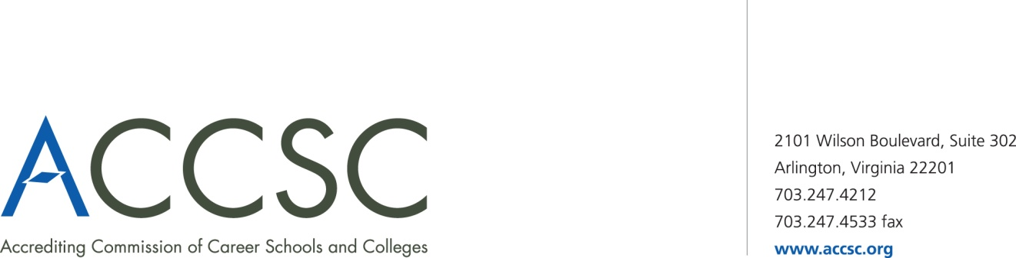**INSTITUTIONAL DEVELOPMENT**

**PAYMENT SUBMISSION FORM FOR APPLICATION SUBMISSIONS**

|  |  |  |  |
| --- | --- | --- | --- |
| **SCHOOL #(s)** | **SCHOOL NAME(s)** | **CITY** | **STATE** |
|  |  |  |  |

|  |  |  |
| --- | --- | --- |
| **APPLICATION TYPE(s)** | **NAME OF PROGRAM(s)**  (*if applicable*) | **PAYMENT AMOUNT(s)**  (*Enter payment amount for each application type*) |
|  |  |  |

|  |  |
| --- | --- |
| **TOTAL PAYMENT AMOUNT** | **CHECK NUMBER** |
|  |  |

|  |  |  |  |
| --- | --- | --- | --- |
| **NAME OF CONTACT PERSON** | **TITLE** | **PHONE NUMBER** | **EMAIL** |
|  |  |  |  |

**\* Please submit a payment submission form with each check payment.**

**Submit To: Operations Department**

**Accrediting Commission of Career Schools and Colleges**

**2101 Wilson Boulevard, Suite 302**

**Arlington, VA 22201**