Each ACCSC-accredited institution that completes a, ACCSC approved change of control must submit this application to the Commission within 45 days following the change of control pursuant to Section IV (E)(2)(o), Rules of Process and Procedure, Standards of Accreditation.

GUIDELINES FOR SUBMISSION - PLEASE REVEW PRIOR TO SUBMISSION:
1. The school must ensure that the Payment Submission Form of this application is included and identifies the correct fee amount, check information, and indicates the correct and applicable school(s).
2. The school must provide a response and all appropriate supporting documentation to all items below. The Commission may not process the application and may require a new submission from the school if the application is found to be incomplete.
3. The completed application should not exceed 100 pages total and should include only the required information. Do not provide copies of the school catalog or information that does not pertain to the items in this application.
4. Prior to final submission of this application, review the entire submission to ensure that all required information is provided, that all intended attachments are included, and that the submission is free of errors and typos.
ELECTRONIC SUBMISSION FORMAT REQUIREMENTS:
- Electronic Submissions may not be transmitted to the Commission via e-mail.
- The school’s response must be prepared in accordance with ACCSC’s Instructions for Electronic Submission (e.g., prepared as one Portable Document Format (“PDF”) file that has been prepared using Adobe Acrobat software (version 8.0 or higher) and which has a .pdf extension as part of the file name). The school will receive an e-mail confirmation that the file has been received within 24 hours of the submission.
- Please visit the ACCSC website for specific resources and guidance regarding how to successfully complete this application: Forms and Reports-Guidance/Sample Applications. ACCSC encourages the school to review this module prior to submitting this application.
- Additionally, do not copy and paste answers from previous applications.

I have read and understand the Guidelines for Submission and the Electronic Document Format Requirements set forth above and I further understand that a failure to adhere to these guidelines and requirements will result in either a delay in the processing of or return of this application.

Name | Signature | Title | Date

School # | School Name | Type
 |  | Main: | ☐
 |  | Branch: | ☐

Address | City, State

Current School Director | Phone | Email
Contact Person | Phone | Email

Date of Change of Control:
Current Student Enrollment:

CERTIFICATION AND ATTESTATION
- I certify that, to the best of my knowledge and belief, the information herein and attached hereto is accurate and correct and that the school will continue to operate in accordance with the standards published by the Commission.
- I certify that I understand that it is the school’s responsibility to demonstrate compliance with the Standards of Accreditation and that the Commission’s deliberations and decisions are made on the basis of the written record and are therefore dependent on the forthrightness of the school in disclosing all information that the Commission has requested on this application.
Current Owner and/or Chief Executive Officer:
Name: |  | Title:
Signature: |  | Date:

APPLICATION PROCESSING FEE
Please payment directly to ACCSC for the processing fee and include a statement identifying the corresponding application(s). Note: Please ensure that the Payment Submission Form for this application is included.
- $750 for a Main School
- $500 for each Branch Campus

APPLICATION ATTACHMENTS
- A complete and detailed explanation of the current (new) control structure to include:
a. A description of any changes made to board membership, managers, and/or partners affiliated with the control structure as compared to the representations made in the Application for a Change of Control-Part I. If any changes or additions have been made to the board membership, managers, and/or partners affiliated with the control structure or to the school management staff following the change of control as presented in the Application for a Change of Control-Part I, provide the following:
i. A detailed description of these changes and how these changes ensure the continued operation of the school in accordance with the Standards of Accreditation and
ii. A listing of any new individual added to the ownership, board, or management structure along with a detailed description of each individual’s education and experience and how each new individual is qualified to fulfill their role.
b. The current form of control (e.g., sole proprietorship, partnership, corporation, non-profit corporation, publicly owned entity, board, family trust, etc.).
c. A description and diagram that sets forth the precise breakdown of the new control structure (e.g., sole proprietorship, partnership, corporation, non-profit corporation, publicly owned entity, board, etc.) including the percentage of ownership (as appropriate) of each entity in the chain of control, up to and including the individual(s) who are the ultimate owners or members of the governing entity (i.e., board). The ownership descriptions/breakdowns must include all individuals, partnerships, LLCs, corporations, trusts, boards, or other forms of ownership and/or governing entity (for publicly traded corporations, this includes shareholders that directly own 10% or more of the stock as of the date of the application).
2. An audited balance sheet with appropriate accounting notes that reflects the financial condition of the school as of the date of the change of control, prepared in accordance with the ACCSC Instructions for the Preparation and Submission of Financial Statements and Related Information.
NOTE: Please contact the ACCSC office regarding the timeframe for preparing and submitting the audited balance sheet if the school cannot complete this requirement at the time that the Application for a Change of Control-Part II is due.
3. A copy of state certification authorizing continuing licensure under the new ownership/governing entity.
4. A copy of the final contract or agreement, signed by all parties, which finalizes the transfer of control of the school.
5. Any other information that is relevant to or may assist the Commission in its review of the information set forth in response to this application and the school’s continuing compliance with accrediting standards.

SUBMIT TO: Executive Director
Accrediting Commission of Career Schools and Colleges
2101 Wilson Boulevard, Suite 302
Arlington, Virginia 22201

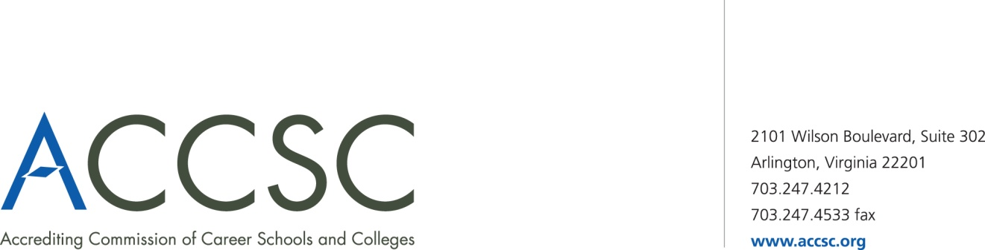
INSTITUTIONAL DEVELOPMENT: PAYMENT SUBMISSION FORM FOR APPLICATION SUBMISSIONS

School(s) # | School(s)  (Please list all schools applicable to payment) | City | State

Application Type(s)  *Please refer to attached list for application types | Payment Amount(s)  (Enter payment amount for each application type)

Total Payment Amount | Check Number

Name of contact person(s) | Title(s) | Contact phone number(s) | Contact email(s)

- Please submit this payment form with each check payment.

Submit To: Operations Department
Accrediting Commission of Career Schools and Colleges
2101 Wilson Boulevard, Suite 302
Arlington, VA 22201

*Application Type(s)

Application of Hours for Clock Hour Programs | Application for Continuing Education and Avocational Courses | Application for Approval of a Baccalaureate Degree
Application for Approval of an Academic Associates Degree | Application for Approval of a Master’s Degree | Application for Approval of an Occupational Associates Degree
Application for a Branch Part I | Application for a Branch Part II | Application for a Branch Realignment, Part I
Application for a Branch Realignment, Part II | Application for a Change of Location Part I | Application for a Change of Location Part I
Application for a Change of Name Part I | Application for a Change of Control Part I | Application for a Change of Control Part II
Application for Clock to Credit Hour Conversion | Application for a Distance Education Facility | Application for Initial Distance Education
Application for Expansion of Distance Education Approval | Application for a Change of Mission | Application for English as a Second Language Courses
Application for a Non-Degree Program | Application for a Satellite Location | Application for a Substantive Program Modification
Application for a Substantive Program Modification Addition of Concentration | Modification of Ownership Report | Consortium Partnership Report
Distance Education Consortium Partnership Agreement | Facility Expansion Report | Program Modification Report Non-substantive Modification
Application for a Baccalaureate Degree – Affiliated | Application for an Associate Degree – Affiliated | Application for a Non-Degree Program – Affiliated
Application for a Substantive Program Modification – Affiliated | Application for a Clock to Credit Hour Conversation – Affiliated | Program Modification – Non Substantive Modification – Affiliated
Application for use of “University” in the School Name Part – I | Application for use of “University” in the School Name Part – II | Application for a Change of Name Part II
Application for a Non-Degree Program with Expansion of Distance Education | Application for Approval of an Associate Degree Program with Expansion of Distance Education

